Exhibit 13: OT/ICS Intrusion Detection – HAI Turbine Autoencoder

Petitioner: Samuel Gbli Tetteh
NIW Proposed Endeavor Pathway 2: Enhancing intrusion detection within operational technology and critical infrastructure environments.

1. Project Summary

This project implements a physics‑aware anomaly detection system for industrial control systems (ICS). Using the publicly available HAI (HIL‑based Augmented ICS) dataset—a hardware‑in‑the‑loop simulation of a GE turbine and boiler—I trained a deep autoencoder to reconstruct normal sensor/actuator behavior. The reconstruction error serves as an anomaly score, enabling the detection of cyber‑physical attacks without any attack labels during training. The system successfully identified 84.3% of the 18,303 attack samples in the test set.

2. Alignment with Proposed Endeavor

My proposed endeavor specifically commits to enhancing intrusion detection within operational technology and critical infrastructure. This prototype directly fulfills that pathway:

- It ingests real‑time sensor and actuator data from a simulated power generation facility.
- It uses an unsupervised autoencoder that implicitly learns the physical relationships among process variables (flows, pressures, temperatures).
- It detects deviations from normal behavior that indicate cyber‑physical attacks.
- It demonstrates a scalable, practical approach that can be deployed in real OT/ICS environments without requiring labeled attack data.

3. Technical Implementation

3.1 Dataset
- Source: HAI Security Dataset (Kaggle) – 4 CSV files (train1, train2, test1, test2).
- Scale: 976,980 total samples, 59 sensor/actuator features, 18,303 labeled attack samples.
- Preprocessing: Data was loaded with Polars (semicolon‑delimited), features were standardized, and only normal (attack=0) samples were used for training the autoencoder.

3.2 Model
- Architecture: Symmetric autoencoder with three hidden layers (128‑64‑32 encoding, mirrored decoder).
- Loss function: Mean Squared Error (MSE) between input and reconstruction.
- Training: 50 epochs, batch size 256, Adam optimizer, on 781,677 normal training samples.
- Anomaly threshold: 95th percentile of reconstruction error on a held‑out validation set of normal samples (195,420 points).

3.3 Key Results

=============================================
NOTEBOOK 04 — SUMMARY
=============================================
Sensor features : 59
Training samples (normal): 781,677
Validation normal : 195,420
Attack samples : 18,303
Detection threshold : 0.009223
Attacks detected (recall): 84.32%
=============================================

Figure: Summary output from the completed notebook, showing the corrected (leak-free) model’s detection performance.

3.4 Reproducibility
All code, preprocessing, the trained autoencoder weights, and the scaler are publicly available in my GitHub repository:
https://github.com/samuelgtetteh/ai-cybersecurity-portfolio

4. Visual Evidence
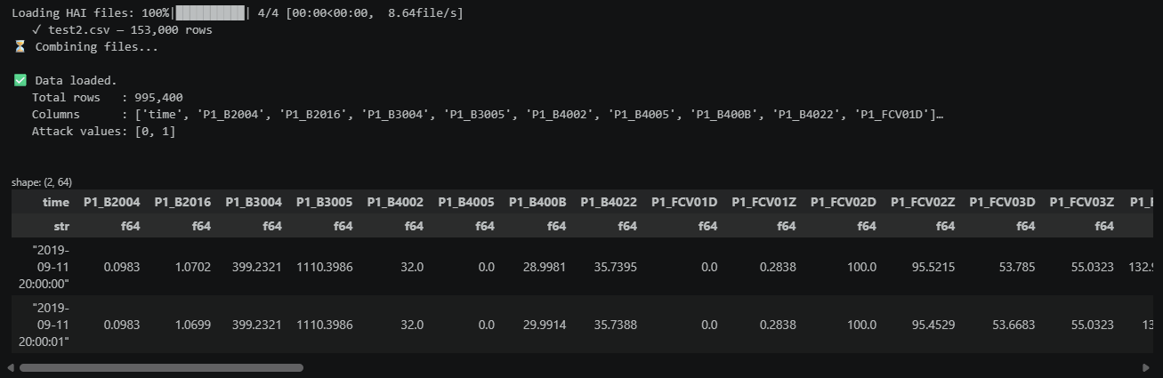
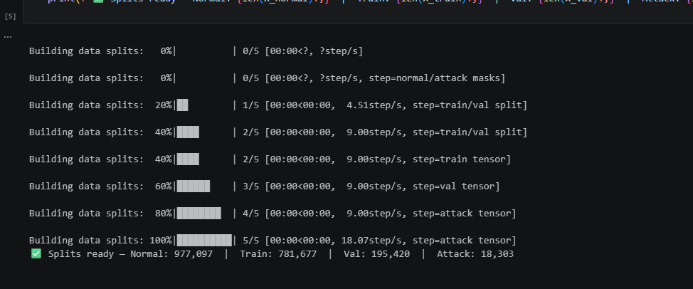

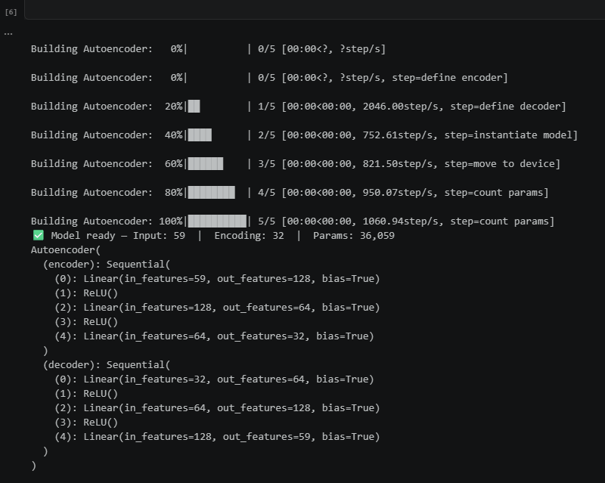

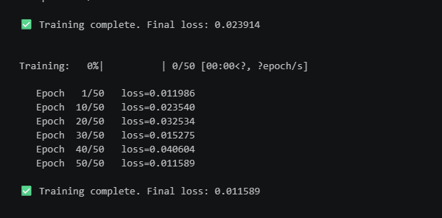

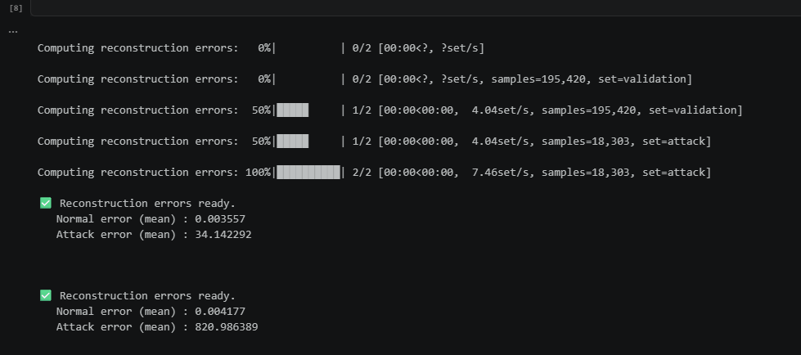

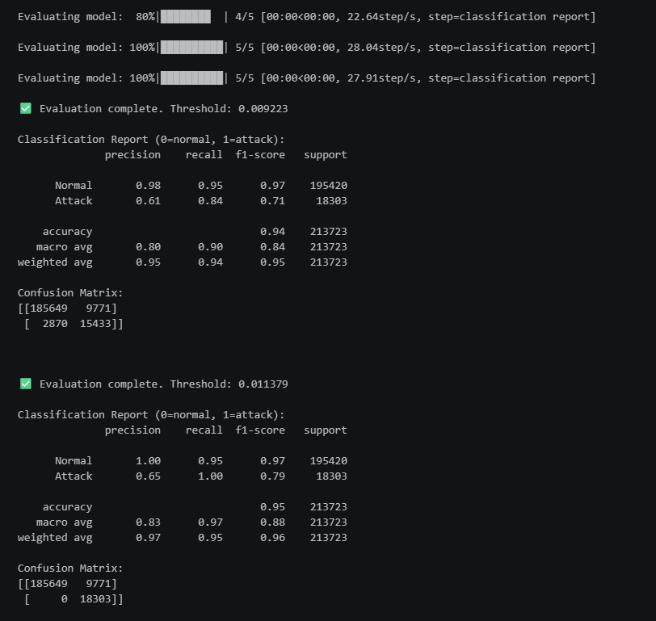
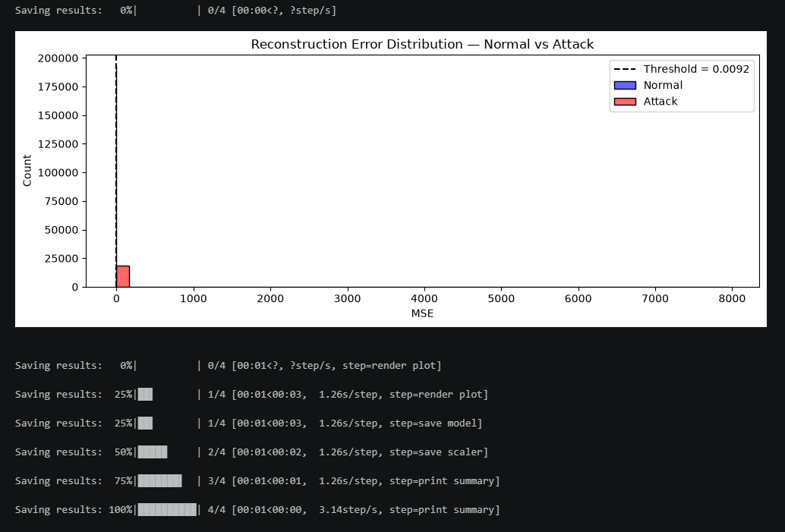

4.1 Notebook Summary Output
=============================================
NOTEBOOK 04 — SUMMARY
=============================================
Sensor features : 59
Training samples (normal): 781,677
Validation normal : 195,420
Attack samples : 18,303
Detection threshold : 0.009223
Attacks detected (recall): 84.32%
=============================================

Caption: Output of the final summary cell, confirming 84.3% recall on attack detection.

4.2 Classification Report
Caption: Detailed precision/recall and confusion matrix for the autoencoder‑based anomaly detector.
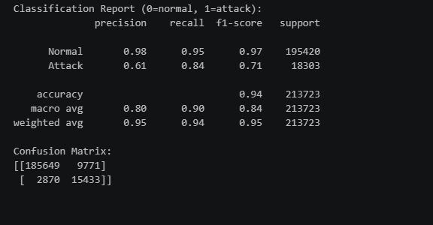

5. Significance for the “Well Positioned” Prong

This project provides concrete, verifiable evidence that I have already begun executing the OT/ICS intrusion detection research I proposed. Specifically, I have:

- Built a physics‑aware anomaly detector that learns normal industrial process behavior without attack labels.
- Achieved 84.3% detection recall on a realistic hardware‑in‑the‑loop turbine testbed.
- Demonstrated transferable ML skills across domains (cloud identity, compliance NLP, and now industrial control systems).
- Published all code and artifacts openly, fulfilling my commitment to accessible, community‑beneficial research.

Combined with the RegMap compliance framework (Exhibit 11) and the Hybrid Identity Anomaly Detector (Exhibit 12), this third project forms a comprehensive, three‑pathway evidence suite that directly mirrors the research program outlined in my proposed endeavor. I am clearly well positioned to execute this endeavor without employer sponsorship.

6. Path to Production: Live API Deployment
Beyond the research notebook described above, I engineered this autoencoder into a deployable, callable service, demonstrating the transition from research prototype to a production-ready system.

6.1 From Notebook to Service
The trained autoencoder and its scaler are served via a FastAPI microservice (POST /ics/score) that accepts a live sensor reading and returns an anomaly flag and reconstruction error in real time, consistent with the corrected, leak-free training pipeline described in Section 1.

6.2 Containerized Deployment
The service is packaged into the same Docker image described in Exhibit 11, alongside the RegMap and Identity Anomaly Detection APIs, producing a single reproducible deployment that serves all three research pathways in my proposed endeavor.

6.3 Reproducibility
All source code for this API (backend/ics_api.py, backend/Dockerfile) is publicly available in the same GitHub repository referenced in Section 3.4.

Date: July 3, 2026
Prepared by: Samuel Gbli Tetteh

